You’re invited to a Paparazzi You’re invited to a Paparazzi

Jewelry Party! Open House! Jewelry Party! Open house!

**Everything is only $5!**  **Everything is only $5!**

**Host: Host:**

**Where: Where:**

**When: When:**

**Drawings for Great Prizes! Drawings for Great Prizes!**

**Hot New Inventory! Over 500 Pieces!**  **Hot New Inventory! Over 500 pieces!**

**Consultant: Consultant:**

**Your Phone Number and ID # Your phone number and ID #**

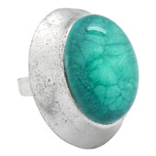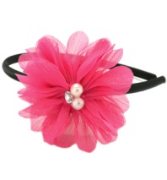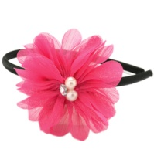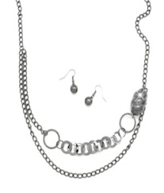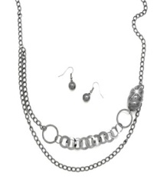

You’re invited to a Paparazzi You’re invited to a Paparazzi

Jewelry Party! Open House! Jewelry Party! Open house!

**Everything is only $5!**  **Everything is only $5!**

**Host: Host:**

**Where: Where:**

**When: When:**

**Drawings for Great Prizes! Drawings for Great Prizes!**

**Hot New Inventory! Over 500 Pieces!**  **Hot New Inventory! Over 500 pieces!**

**Consultant: Consultant:**

**Your Phone Number and ID # Your phone number and ID #**

